# DATABASE IPLEMENTATION REPORT

Contents

DATABASE IPLEMENTATION REPORT 1

PROJECT SUMMARY 3

ENTITY AND ATTRIBUTE TABLE 4

ENTITY-RELATIONSHIP DIAGRAM 5

CREATION OF TABLES 6

MAJOR DATA QUESTIONS 7

INTERFACES 8

REPORT 9

# PROJECT SUMMARY

Publication company issues magazines every month both physical and e-book copies. Customers can choose to subscribe for 3 months, 6 months or 12 months. The company also publishes the advertisements in each issue. Thus, company has to deal with large amount of data generated through several means.

The objective of the project is to create the database management system that will assist the Publication Company in their process. The company deals with business scenarios such as, number of magazines published so far, number of active subscriptions, subscription period of each customer, name and other details of the customers, region where all these customers belong to, name of the advertisers who publish advertisements in the magazine, number of advertisements in each issue of magazine. The company needs to keep track of revenue generated from subscription of the physical book each month, and the revenue generated from the subscription of the e-book. They also need to identify the region of advertisement clients, which region has more number of subscribers.

Currently subscribers are subscribing to the magazine through the company website via google form like user interface. The data gets collected in excel spreadsheets in the backend. The publication company must deal with lot of data transactions like active subscribers activating and cancelling their subscription. It will have to be updated in the excel spreadsheet and/or the physical file manually. Company employees have to manually list down the subscribers region-wise and if they wanted the list of issue wise advertisers that would be a strenuous process. This will be resolved through the proposed system. The expenditure through various means are updated into the system and therefore can be tracked monthly i.e. expenditure incurred while publishing every issue of the magazine along with the details regarding the number of customers

The purpose of this system is to increase automation and reduce manual effort. The proposed system is a well-structured database that will store all the required information and will retrieve the data for the user by the data management team of the magazine whenever necessary in an astute manner. It stores the information in table format. This will reduce the manual intervention to a bare minimum and this will in-turn reduce the number of errors while handling the transactions.

This report will present the system design of the proposed system, its entities, attributes along with their function and relationship between them. The entity relationship diagram (ERD) will explain the relationship between all the entities in the database in a pictorial manner. It will also provide the cardinality between the entities. This report will also comprise of the table providing the description of the entities along with business rules that define the function of the database and answer major data questions that are required by the users.

# ENTITY AND ATTRIBUTE TABLE

|  |  |  |  |  |
| --- | --- | --- | --- | --- |
| ENTITY NAME:  Customer | ATTRIBUTE NAME | FIELD TYPE | NULL/NOT NULL | EXPLANATION |
| PRIMARY KEY | CustomerID | INT | NOT NULL | Unique Identifier for Customer Entity; CustomerID is given by Company employees. |
| OTHER ATTRIBUTES | CFName | VARCHAR(80) | NOT NULL | First Name of the customer |
|  | CFMname | VARCHAR(80) | NOT NULL | Middle name of the customer |
|  | CLName | VARCHAR(80) | NOT NULL | Last name of the customer |
|  | CType | INT | NOT NULL | Type of subscription the customer has |
|  | CEmail | VARCHAR(80) | NOT NULL | Customer Email ID |
|  | CPhone | VARCHAR(20) | NOT NULL | Phone number of the customer |
|  | CApt | VARCHAR(50) | NOT NULL | Apartment number of customer |
|  | CStreet | VARCHAR(80) | NOT NULL | Street number of Customer address |
|  | CCity | VARCHAR(80) | NOT NULL | City Name of Customer Address |
|  | CStateID | CHAR(2) | NOT NULL | State ID |
|  | CCountry | VARCHAR(80) | NOT NULL | Country Name |
|  | CZip | BIGINT | NOT NULL | Zip Code |

1. Customer – This entity captures information about the customer who subscribed for the magazines.
2. Magazine - This entity captures information about the Magazines sold by company.

|  |  |  |  |  |
| --- | --- | --- | --- | --- |
| ENTITY NAME:  Customer | ATTRIBUTE NAME | FIELD TYPE | NULL/NOT NULL | EXPLANATION |
| PRIMARY KEY | MagazineID | VARCHAR(20) | NOT NULL | Unique Identifier for Magazine Entity; MagazineID  is assigned by Company employees. |
| OTHER ATTRIBUTES | MagazineName | VARCHAR(20) | NOT NULL | Name of the Magazine |

1. SubMagType - This entity captures information about the Magazines and subscriber relationship.

|  |  |  |  |  |
| --- | --- | --- | --- | --- |
| ENTITY NAME:  Customer | ATTRIBUTE NAME | FIELD TYPE | NULL/NOT NULL | EXPLANATION |
| PRIMARY KEY | SubMagTypeID | INT | NOT NULL | Unique Identifier for each Magazine and Subscription Entity; SubMagTypeID is assigned by Company employees. |
| OTHER ATTRIBUTES | MagID | VARCHAR (20) | NOT NULL | ID of the magazine to which this subscription belongs |
|  | SubPeriod | INT | NOT NULL | Duration of the subscription which is 3/6/12 |
|  | SubCost | INT | NOT NULL | Cost of the particular subscription |

1. Advertisement - This entity captures information about the Advertisements and client information.

|  |  |  |  |  |
| --- | --- | --- | --- | --- |
| ENTITY NAME:  Customer | ATTRIBUTE NAME | FIELD TYPE | NULL/NOT NULL | EXPLANATION |
| PRIMARY KEY | AdvertID | INT | NOT NULL | Unique Identifier for Advertisement Entity; AdvertID  is assigned by Company employees. |
| OTHER ATTRIBUTES | ClientName | VARCHAR (20) | NOT NULL | Name of the client who advertised |
|  | ClientStateID | CHAR | NOT NULL | ID of the State from which this advertisement was published |

1. AdvertTracker - This entity captures information, which Advertisements are published in which issue of Magazine.

|  |  |  |  |  |
| --- | --- | --- | --- | --- |
| ENTITY NAME:  Customer | ATTRIBUTE NAME | FIELD TYPE | NULL/NOT NULL | EXPLANATION |
| PRIMARY KEY | IssueID | INT | NOT NULL | Unique Identifier for AdvertTracker Entity; Part of Composite Primary Key. |
| PRIMARY KEY | AdvertID | INT | NOT NULL | Unique Identifier for AdvertTracker Entity; Part of Composite Primary Key. |
| OTHER ATTRIBUTES | AdvertisementCost | INT | NOT NULL | Cost of each advertisement. |

1. Subscription - This entity captures information, which Subscription are published in which issue of Magazine.

|  |  |  |  |  |
| --- | --- | --- | --- | --- |
| ENTITY NAME:  Customer | ATTRIBUTE NAME | FIELD TYPE | NULL/NOT NULL | EXPLANATION |
| PRIMARY KEY | SubID | INT | NOT NULL | Unique Identifier for Subscription Entity; SubID is assigned by Company employees. |
| OTHER ATTRIBUTES | SCustomerID | INT | NOT NULL | ID of the customer who subscribed the magazine |
|  | SSubMagtypeID | INT | NOT NULL | ID that identifies the duration of the subscription |
|  | SubStartDate | DATE | NOT NULL | Month from which the subscription start |
|  | SubEndDate | DATE | NOT NULL | Month when the subscription ends. |

1. Issue - This entity captures information, which Subscription are published in which issue of Magazine.

|  |  |  |  |  |
| --- | --- | --- | --- | --- |
| ENTITY NAME:  Customer | ATTRIBUTE NAME | FIELD TYPE | NULL/NOT NULL | EXPLANATION |
| PRIMARY KEY | IssueID | INT | NOT NULL | Unique Identifier for Issue Entity; IssueID is assigned by Company employees. |
| OTHER ATTRIBUTES | IMagazineID | VARCHAR (20) | NOT NULL | Uniquely identifies the Magazines. |
|  | Month | VARCHAR(10) | NOT NULL | Month for each Issue. |

1. States- This entity captures information about the States to which each Customer belongs.

|  |  |  |  |  |
| --- | --- | --- | --- | --- |
| ENTITY NAME:  Customer | ATTRIBUTE NAME | FIELD TYPE | NULL/NOT NULL | EXPLANATION |
| PRIMARY KEY | StateID | char(2) | NOT NULL | Unique Identifier for States Entity; StateID is assigned by Company employees. |
| OTHER ATTRIBUTES | StateName | VARCHAR (20) | NOT NULL | State name to which Customer belongs. |

# ENTITY-RELATIONSHIP DIAGRAM

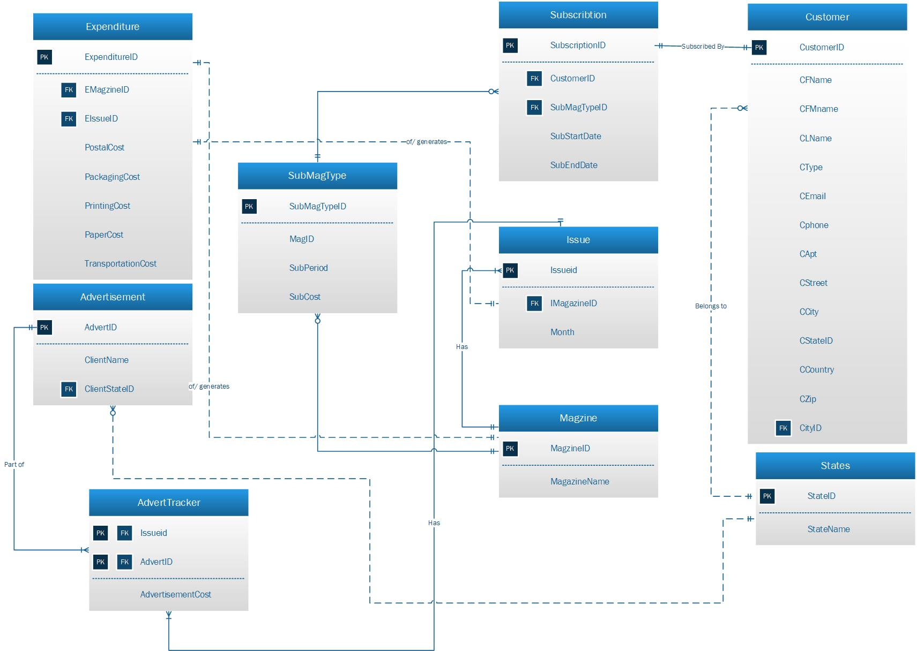

# CREATION OF TABLES

Magazine:

CREATE TABLE Magazine(

MagazineID VARCHAR(20),

MagazineName VARCHAR(20),

PRIMARY KEY (MagazineID));

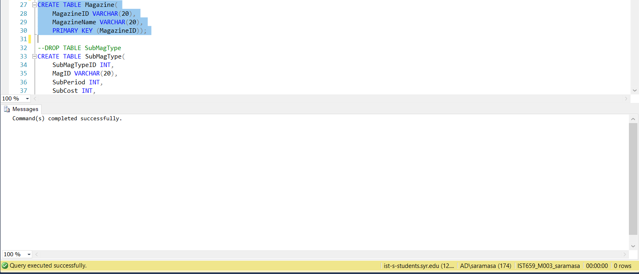

SubMagType:

CREATE TABLE SubMagType(

SubMagTypeID INT,

MagID VARCHAR(20),

SubPeriod INT,

SubCost INT,

PRIMARY KEY (SubMagTypeID),

FOREIGN KEY (MagID) REFERENCES Magazine (MagazineID));

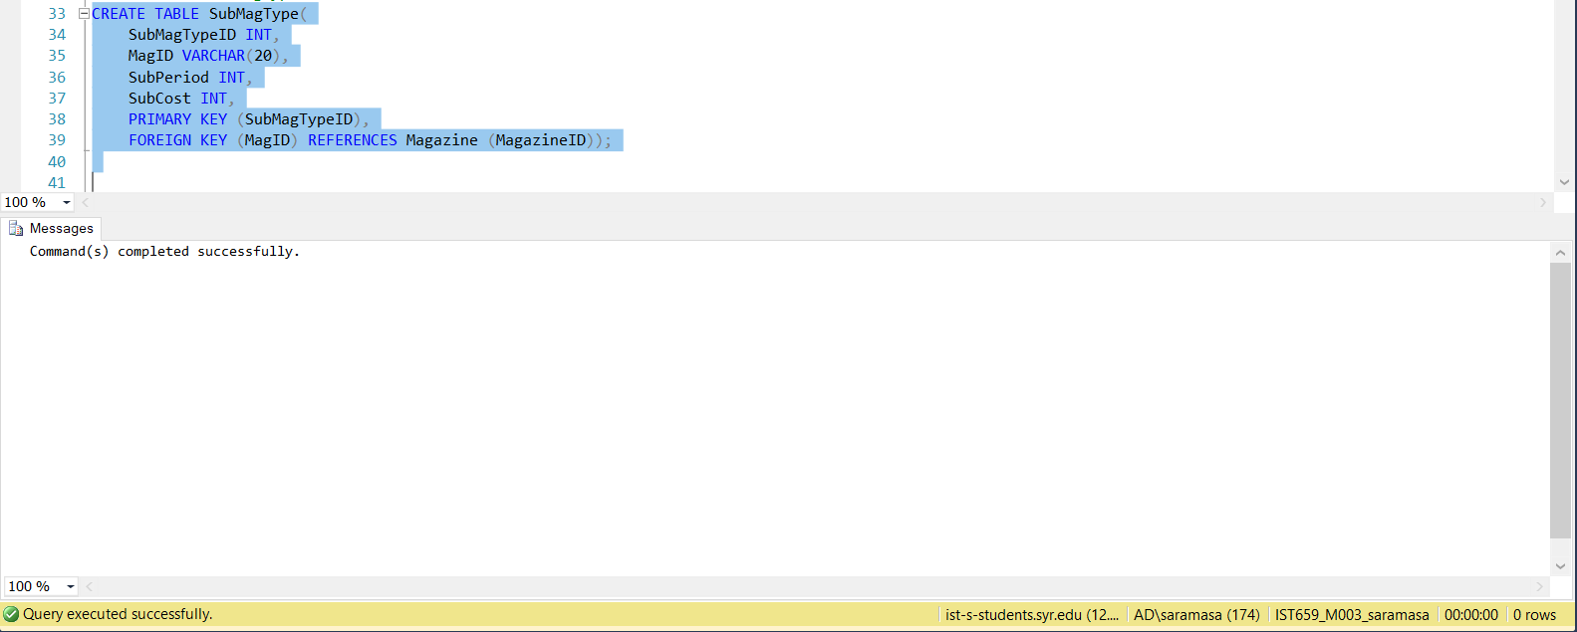

Issue:

CREATE TABLE Issue(

IssueID INT,

IMagazineID VARCHAR(20),

Month VARCHAR(10),

PRIMARY KEY (IssueID),

FOREIGN KEY (IMagazineID) REFERENCES Magazine (MagazineID));

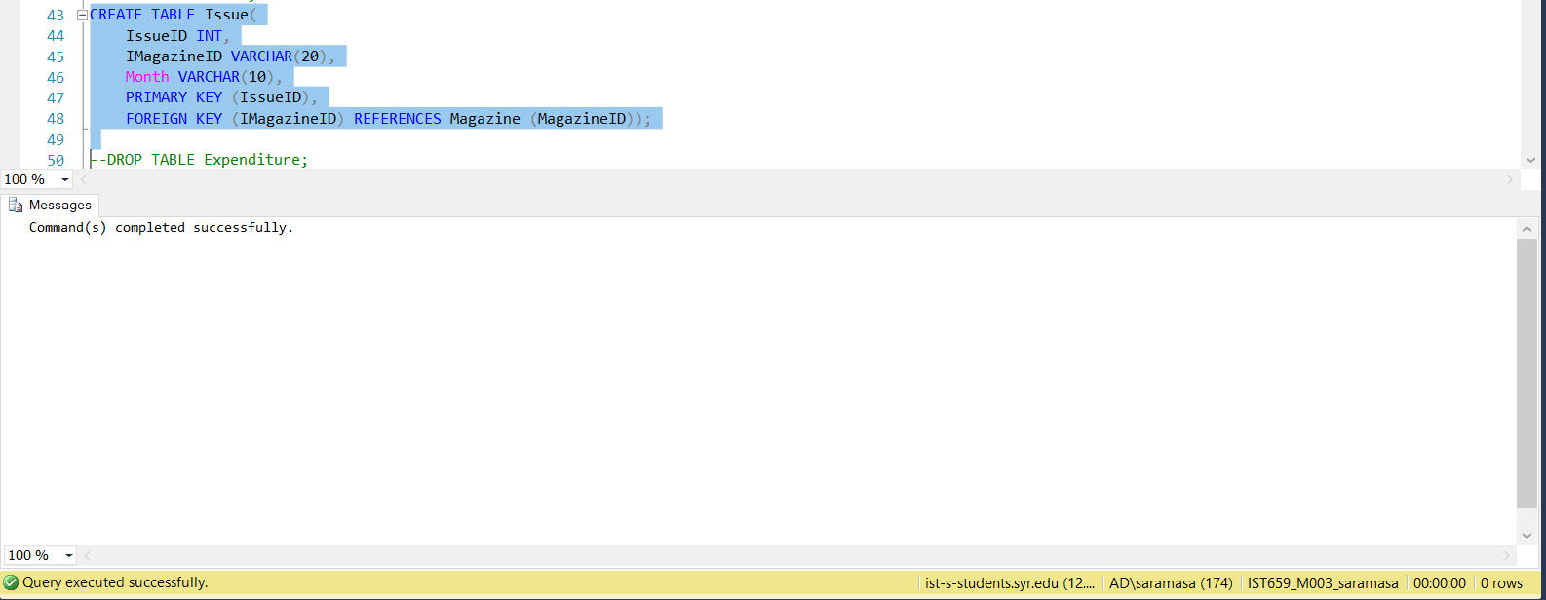

Expenditure:

CREATE TABLE Expenditure(

ExpenditureID INT,

EMagazineID VARCHAR (20) NOT NULL,

EIssueID int not null,

PostalCost INT NOT NULL,

PackagingCost INT NOT NULL,

PrintingCost INT NOT NULL,

PaperCost INT NOT NULL,

TransportationCost INT NOT NULL,

PRIMARY KEY (ExpenditureID),

FOREIGN KEY (EMagazineID) REFERENCES Magazine (MagazineID),

FOREIGN KEY (EIssueID) REFERENCES Issue (IssueID));

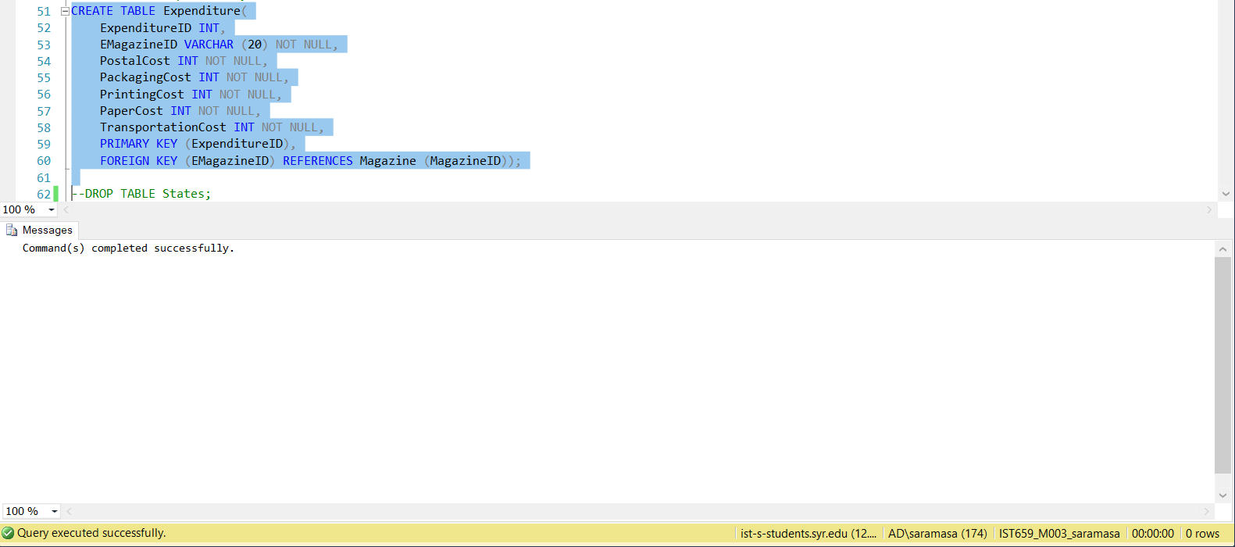

States:

CREATE TABLE States(

StateID char(2),

StateName VARCHAR(20) NOT NULL,

PRIMARY KEY (StateID)

);

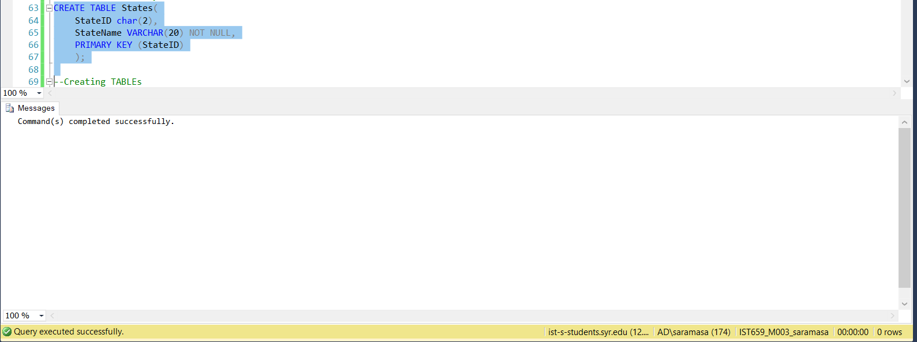

Customer:

CREATE TABLE Customer (

CustomerID INT,

CFName VARCHAR(80) NOT NULL,

CMNName VARCHAR(80),

CLName VARCHAR(80) NOT NULL,

CType INT NOT NULL,

CEmail VARCHAR(80) NOT NULL,

CPhone VARCHAR(20) NOT NULL,

CApt VARCHAR(50) NOT NULL,

CStreet VARCHAR(80) NOT NULL,

CCity VARCHAR(80) NOT NULL,

CStateID char(2) NOT NULL,

CCountry VARCHAR(80) NOT NULL,

CZip BIGINT NOT NULL,

PRIMARY KEY (CustomerID),

FOREIGN KEY (CStateID) REFERENCES States (StateID),

CONSTRAINT chk_customer CHECK (CType in (01,10,11)),

CONSTRAINT chk_customer1 CHECK (Czip<100000),

CONSTRAINT chk_customer2 CHECK (CPhone<9999999999)

);

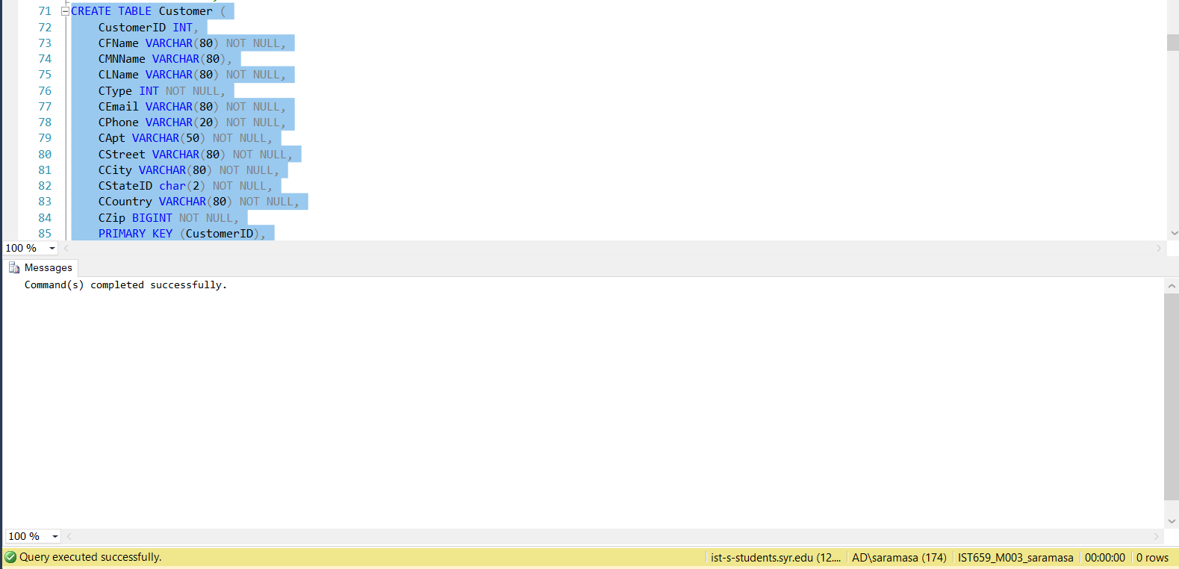

Advertisement:

CREATE TABLE Advertisement(

AdvertID INT,

ClientName VARCHAR(20) NOT NULL,

ClientStateID char(2) NOT NULL

PRIMARY KEY (AdvertID),

FOREIGN KEY (ClientStateID) REFERENCES States (StateID)

);

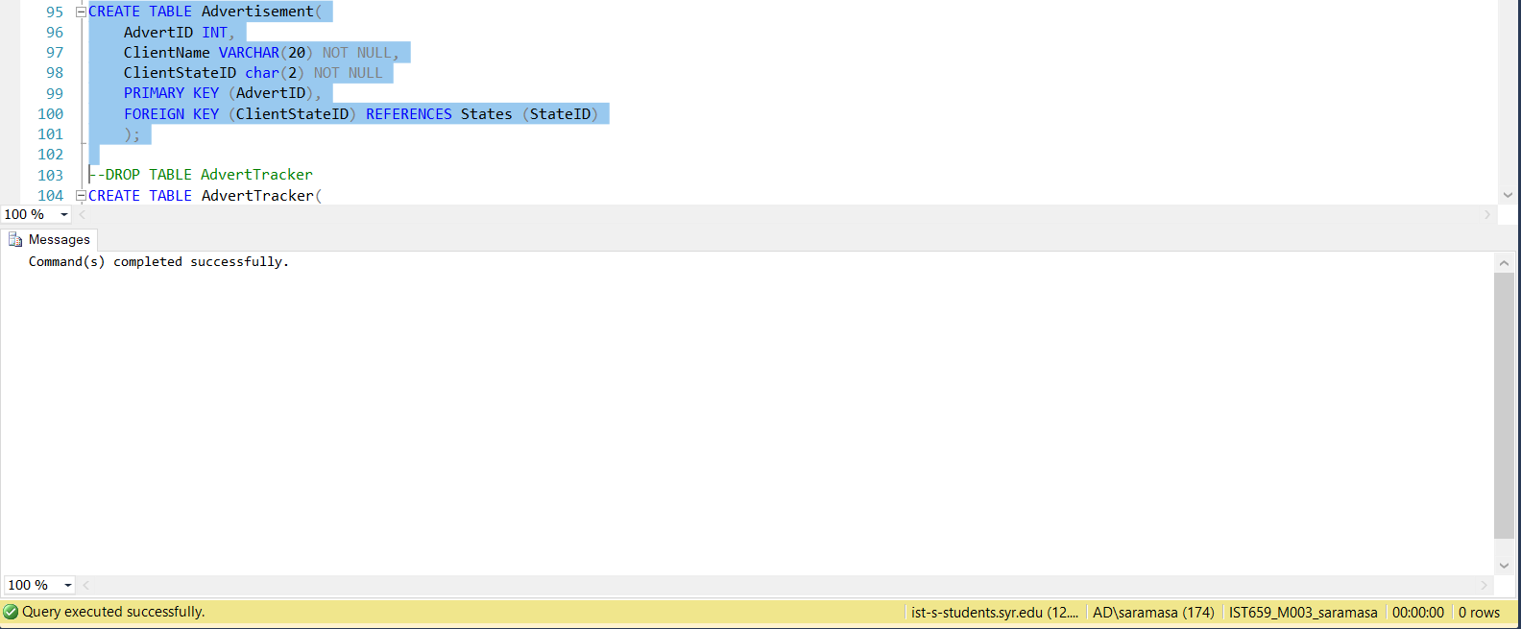

AdvertTracker:

CREATE TABLE AdvertTracker(

IssueID INT,

AdvertID INT,

AdvertisementCost INT,

PRIMARY KEY (IssueID, AdvertID),

);

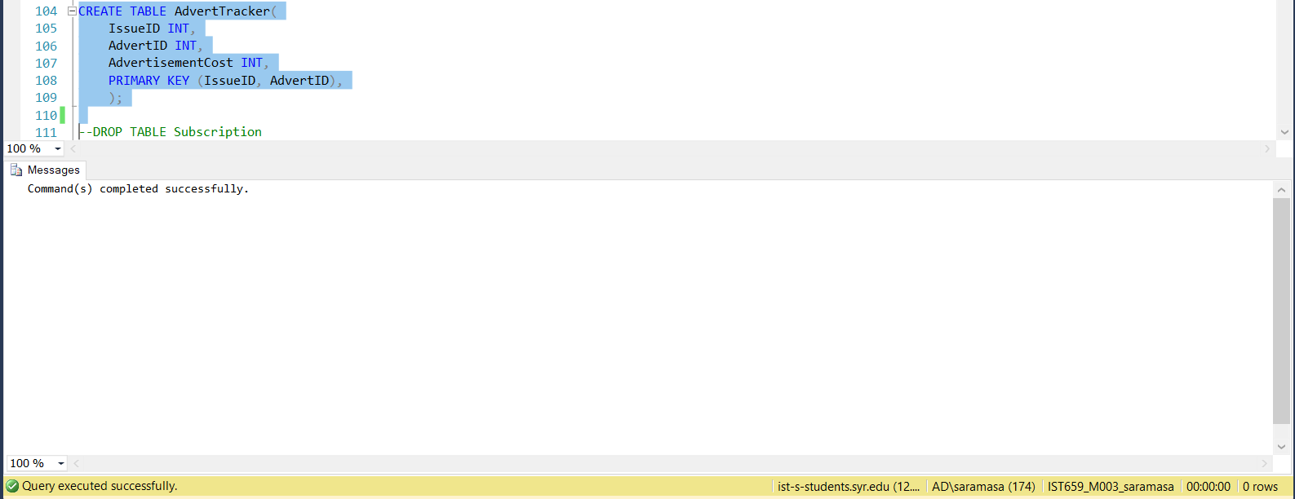

Subscription:

CREATE TABLE Subscription(

SubID INT,

SCustomerID INT,

SSubMagtypeID INT,

SubStartDate date,

SubEndDate date

PRIMARY KEY (SubID),

FOREIGN KEY (SCustomerID) REFERENCES Customer (CustomerID),

FOREIGN KEY (SSubMagTypeID) REFERENCES SubMagType (SubMagTypeID));

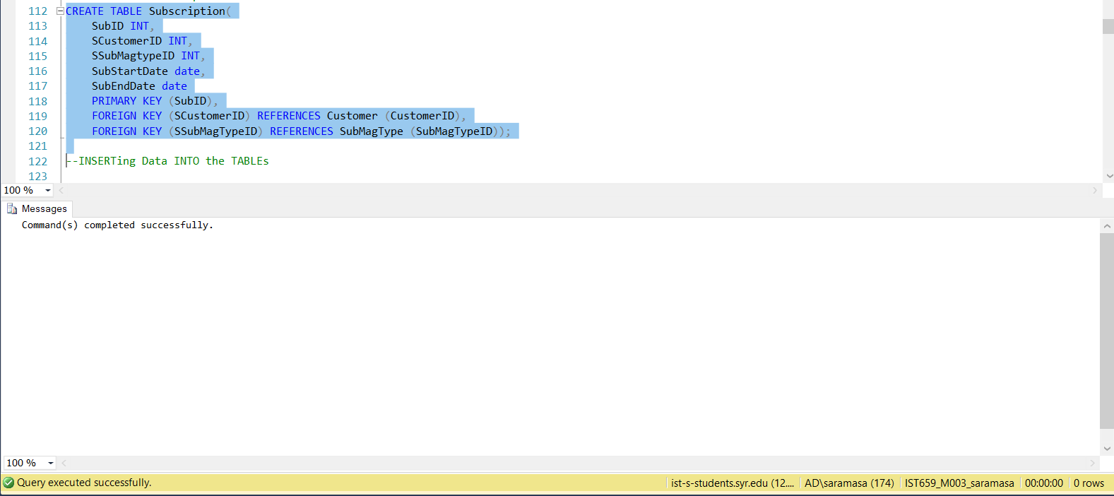

Inserting Data:

--INSERTing Data INTO the TABLEs

--States

INSERT INTO States VALUES ('NY','New York');

INSERT INTO States VALUES('AL','Alabama')

INSERT INTO States VALUES('AK','Alaska')

INSERT INTO States VALUES('AZ','Arizona')

INSERT INTO States VALUES('AR','Arkansas')

INSERT INTO States VALUES('CA','California')

INSERT INTO States VALUES('CO','Colorado')

INSERT INTO States VALUES('CT','Connecticut')

INSERT INTO States VALUES('DE','Delaware')

INSERT INTO States VALUES('DC','District of Columbia')

INSERT INTO States VALUES('FL','Florida')

INSERT INTO States VALUES('GA','Georgia')

INSERT INTO States VALUES('HI','Hawaii')

INSERT INTO States VALUES('ID','Idaho')

INSERT INTO States VALUES('IL','Illinois')

INSERT INTO States VALUES('IN','Indiana')

INSERT INTO States VALUES('IA','Iowa')

INSERT INTO States VALUES('KS','Kansas')

INSERT INTO States VALUES('KY','Kentucky')

INSERT INTO States VALUES('LA','Louisiana')

INSERT INTO States VALUES('ME','Maine')

INSERT INTO States VALUES('MT','Montana')

INSERT INTO States VALUES('NE','Nebraska')

INSERT INTO States VALUES('NV','Nevada')

INSERT INTO States VALUES('NH','New Hampshire')

INSERT INTO States VALUES('NJ','New Jersey')

INSERT INTO States VALUES('NM','New Mexico')

INSERT INTO States VALUES('NC','North Carolina')

INSERT INTO States VALUES('ND','North Dakota')

INSERT INTO States VALUES('OH','Ohio')

INSERT INTO States VALUES('OK','Oklahoma')

INSERT INTO States VALUES('OR','Oregon')

INSERT INTO States VALUES('MD','Maryland')

INSERT INTO States VALUES('MA','Massachusetts')

INSERT INTO States VALUES('MI','Michigan')

INSERT INTO States VALUES('MN','Minnesota')

INSERT INTO States VALUES('MS','Mississippi')

INSERT INTO States VALUES('MO','Missouri')

INSERT INTO States VALUES('PA','Pennsylvania')

INSERT INTO States VALUES('RI','Rhode Island')

INSERT INTO States VALUES('SC','South Carolina')

INSERT INTO States VALUES('SD','South Dakota')

INSERT INTO States VALUES('TN','Tennessee')

INSERT INTO States VALUES('TX','Texas')

INSERT INTO States VALUES('UT','Utah')

INSERT INTO States VALUES('VT','Vermont')

INSERT INTO States VALUES('VA','Virginia')

INSERT INTO States VALUES('WA','Washington')

INSERT INTO States VALUES('WV','West Virginia')

INSERT INTO States VALUES('WI','Wisconsin')

INSERT INTO States VALUES('WY','Wyoming')

select * from States

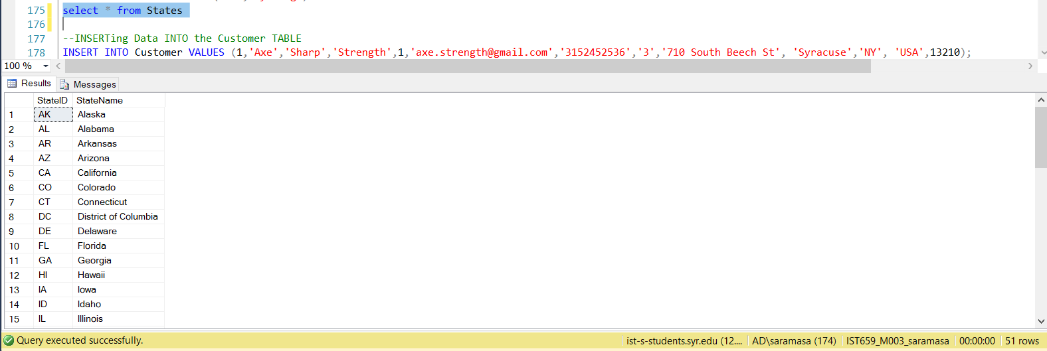

--Inserting data into Advertisement

INSERT INTO Advertisement VALUES (21,'AdCom Pvt Ltd','NY')

INSERT INTO Advertisement VALUES (22, 'TecAdvt Pvt Ltd', 'MI')

insert into Advertisement values (1,'Justina Pvt Ltd','TN')

insert into Advertisement values (2,'Mandy Pvt Ltd','OR')

insert into Advertisement values (3,'Conrad Pvt Ltd','OH')

insert into Advertisement values (4,'Cyril Pvt Ltd','CA')

insert into Advertisement values (5,'Shelley Pvt Ltd','TX')

insert into Advertisement values (6,'Rosalind Pvt Ltd','MN')

insert into Advertisement values (7,'Davis Pvt Ltd','OH')

insert into Advertisement values (8,'Winnie Pvt Ltd','TX')

insert into Advertisement values (9,'Trudy Pvt Ltd','CA')

insert into Advertisement values (10,'Deshawn Pvt Ltd','TX')

insert into Advertisement values (11,'Claudio Pvt Ltd','NJ')

insert into Advertisement values (12,'Sal Pvt Ltd','IN')

insert into Advertisement values (13,'Cristina Pvt Ltd','NY')

insert into Advertisement values (14,'Cary Pvt Ltd','OH')

insert into Advertisement values (15,'Haley Pvt Ltd','CO')

insert into Advertisement values (16,'Dorothea Pvt Ltd','NJ')

insert into Advertisement values (17,'Fannie Pvt Ltd','FL')

insert into Advertisement values (18,'Allyson Pvt Ltd','NJ')

insert into Advertisement values (19,'Roger Pvt Ltd','FL')

insert into Advertisement values (20,'Dollie Pvt Ltd','TX')

SELECT * FROM Advertisement

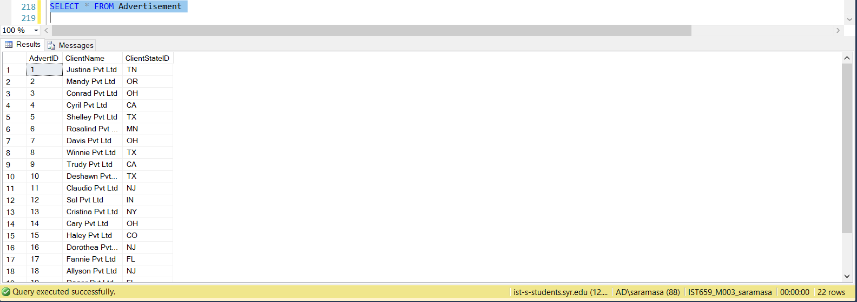

--INSERTing Data INTO the Customer TABLE

INSERT INTO Customer VALUES (1,'Axe','Sharp','Strength',1,'axe.strength@gmail.com','3152452536','3','710 South Beech St', 'Syracuse','NY', 'USA',13210);

INSERT INTO Customer VALUES(2,'Essie','Conrad','Vaill',11,'essie@vaill.com','9073450962','14225','Hancock Dr','Anchorage','AK','United States of America',99515)

INSERT INTO Customer VALUES(3,'Cruz','Cyril','Roudabush',11,'cruz@roudabush.com','6022524827','2202','S Central Ave','Phoenix','AZ','United States of America',85004)

INSERT INTO Customer VALUES(4,'Billie','Shelley','Tinnes',1,'billie@tinnes.com','2128895775','28','W 27th St','New York','NY','United States of America',10001)

INSERT INTO Customer VALUES(5,'Zackary','Rosalind','Mockus',1,'zackary@mockus.com','7324420638','286','State St ','Perth Amboy','NJ','United States of America',8861)

INSERT INTO Customer VALUES(6,'Rosemarie','Davis','Fifield',1,'rosemarie@fifield.com','8088368966','3131','N Nimitz Hwy','Honolulu','HI','United States of America',96819)

INSERT INTO Customer VALUES(7,'Bernard','Winnie','Laboy',10,'bernard@laboy.com','8154670487','22661','S Frontage Rd','Channahon','IL','United States of America',60410)

INSERT INTO Customer VALUES(8,'Sue','Trudy','Haakinson',1,'sue@haakinson.com','6029532753','9617','N Metro Pky','Phoenix','AZ','United States of America',85051)

INSERT INTO Customer VALUES(9,'Valerie','Deshawn','Pou',11,'valerie@pou.com','6103958743','7475','Hamilton Blvd ','Trexlertown','PA','United States of America',18087)

INSERT INTO Customer VALUES(10,'Lashawn','Claudio','Hasty',11,'lashawn@hasty.com','6269606738','815','S Glendora Ave','West Covina','CA','United States of America',91790)

INSERT INTO Customer VALUES(11,'Marianne','Sal','Earman',1,'marianne@earman.com','4078570431','6220','S Orange Blossom','Orlando','FL','United States of America',32809)

SELECT * FROM Customer

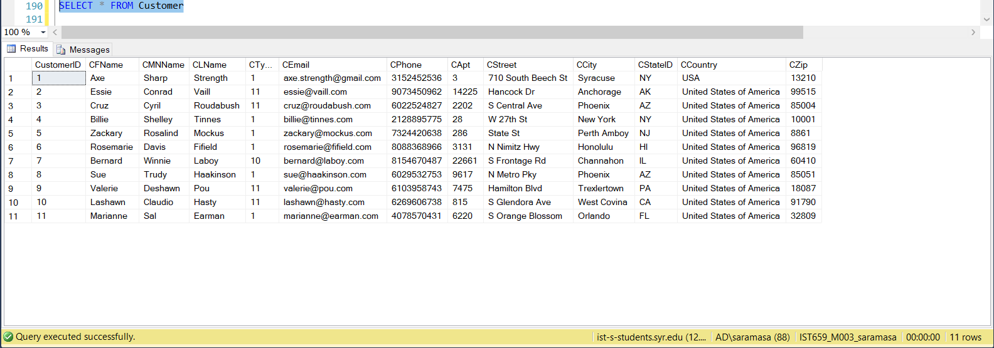

--INSERTING DATA INTO MAGAZINE TABLE

INSERT INTO Magazine VALUES ('VOG','VOGUE');

INSERT INTO Magazine VALUES ('VOG-E','VOGUE');

SELECT * FROM Magazine;

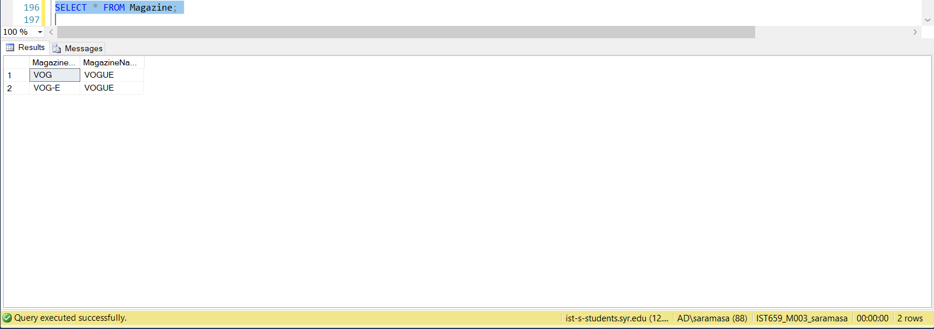

--INESSRTING DATA INTO ISSUE TABLE

INSERT INTO Issue VALUES(1,'VOG','January')

INSERT INTO Issue VALUES(2,'VOG','February')

INSERT INTO Issue VALUES(3,'VOG','March')

INSERT INTO Issue VALUES(4,'VOG','April')

INSERT INTO Issue VALUES(5,'VOG','May')

INSERT INTO Issue VALUES(6,'VOG','June')

INSERT INTO Issue VALUES(7,'VOG','July')

INSERT INTO Issue VALUES(8,'VOG','August')

INSERT INTO Issue VALUES(9,'VOG','September')

INSERT INTO Issue VALUES(10,'VOG','October')

INSERT INTO Issue VALUES(11,'VOG','November')

INSERT INTO Issue VALUES(12,'VOG','December')

INSERT INTO Issue VALUES(13,'VOG-E','January')

INSERT INTO Issue VALUES(14,'VOG-E','February')

INSERT INTO Issue VALUES(15,'VOG-E','March')

INSERT INTO Issue VALUES(16,'VOG-E','April')

INSERT INTO Issue VALUES(17,'VOG-E','May')

INSERT INTO Issue VALUES(18,'VOG-E','June')

INSERT INTO Issue VALUES(19,'VOG-E','July')

INSERT INTO Issue VALUES(20,'VOG-E','August')

INSERT INTO Issue VALUES(21,'VOG-E','September')

INSERT INTO Issue VALUES(22,'VOG-E','October')

INSERT INTO Issue VALUES(23,'VOG-E','November')

INSERT INTO Issue VALUES(24,'VOG-E','December')

SELECT * FROM Issue

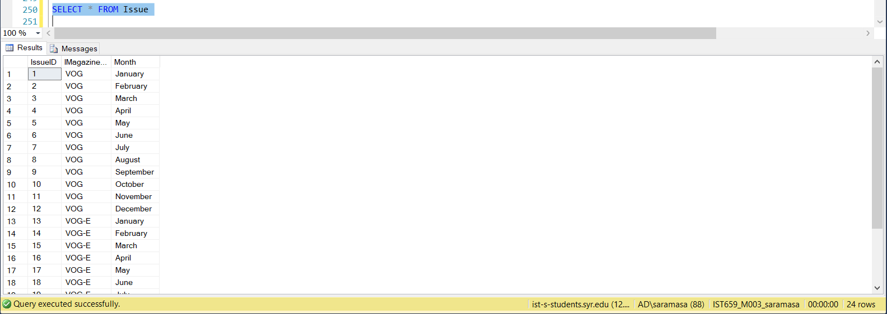

--INSERTING DATA INTO ADVERTTRACKER TABLE

INSERT INTO AdvertTracker VALUES (1,1,6437)

INSERT INTO AdvertTracker VALUES (2,1,5339)

INSERT INTO AdvertTracker VALUES (3,1,8985)

INSERT INTO AdvertTracker VALUES (4,1,6473)

INSERT INTO AdvertTracker VALUES (5,2,6342)

INSERT INTO AdvertTracker VALUES (6,1,5561)

INSERT INTO AdvertTracker VALUES (7,1,5577)

INSERT INTO AdvertTracker VALUES (8,2,5917)

INSERT INTO AdvertTracker VALUES (9,1,9399)

INSERT INTO AdvertTracker VALUES (10,1,6797)

INSERT INTO AdvertTracker VALUES (11,2,9487)

INSERT INTO AdvertTracker VALUES (12,1,9125)

INSERT INTO AdvertTracker VALUES (13,1,6723)

INSERT INTO AdvertTracker VALUES (14,2,6406)

INSERT INTO AdvertTracker VALUES (15,1,7342)

INSERT INTO AdvertTracker VALUES (16,1,9096)

INSERT INTO AdvertTracker VALUES (17,2,8150)

INSERT INTO AdvertTracker VALUES (18,1,7946)

INSERT INTO AdvertTracker VALUES (19,1,8627)

INSERT INTO AdvertTracker VALUES (20,1,7661)

INSERT INTO AdvertTracker VALUES (21,1,7476)

INSERT INTO AdvertTracker VALUES (22,2,6634)

INSERT INTO AdvertTracker VALUES (23,2,6858)

INSERT INTO AdvertTracker VALUES (24,1,9466)

SELECT * FROM AdvertTracker

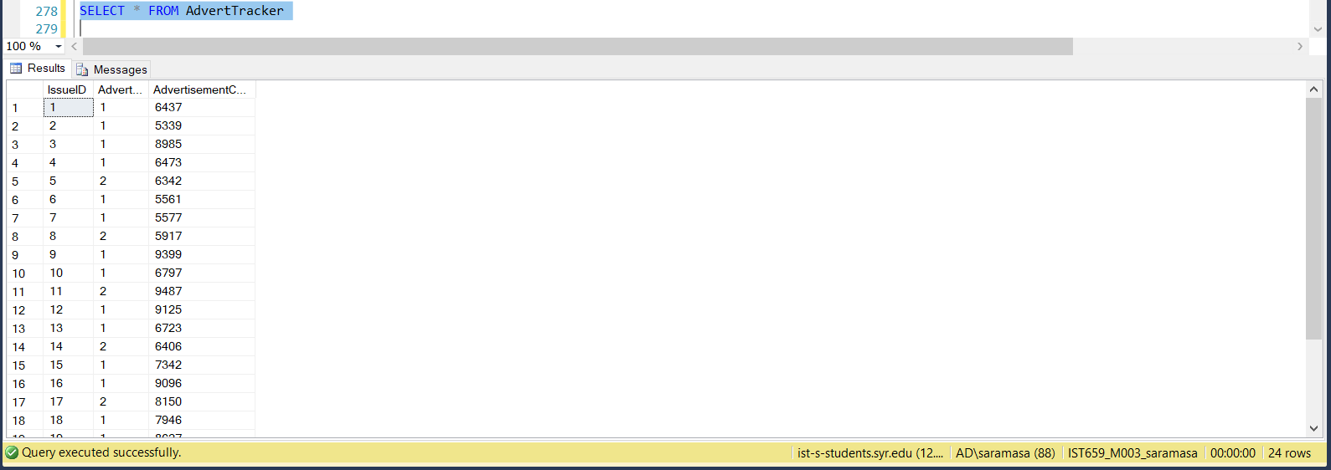

--INSERTING DATA INTO SUBMAGTYPE TABLE

INSERT INTO SubMagType VALUES(1,'VOG',3,69)

INSERT INTO SubMagType VALUES(2,'VOG',6,138)

INSERT INTO SubMagType VALUES(3,'VOG',12,276)

INSERT INTO SubMagType VALUES(4,'VOG-E',3,63)

INSERT INTO SubMagType VALUES(5,'VOG-E',6,126)

INSERT INTO SubMagType VALUES(6,'VOG-E',12,252)

SELECT * FROM SubMagType

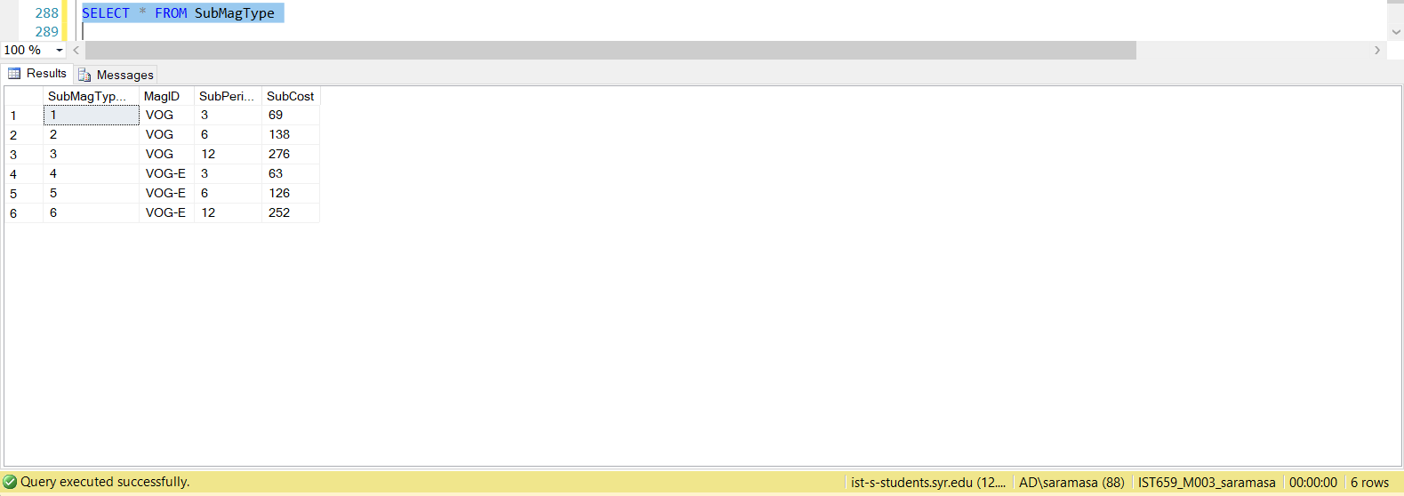

--INSERTING DATA INTO SUBSCRIPTION TABLE

insert into Subscription values (1,10,2,'2018/10/11','2019/04/11')

insert into Subscription values (2,3,2,'2018/11/24','2019/05/24')

insert into Subscription values (3,6,6,'2018/07/24','2019/01/24')

insert into Subscription values (4,6,1,'2018/04/23','2018/10/23')

insert into Subscription values (5,5,4,'2018/08/08','2019/02/08')

insert into Subscription values (6,5,3,'2018/05/20','2018/11/20')

insert into Subscription values (7,10,2,'2018/03/29','2018/09/29')

insert into Subscription values (8,1,2,'2018/01/14','2018/07/14')

insert into Subscription values (9,5,3,'2018/09/08','2019/03/08')

insert into Subscription values (10,10,5,'2018/07/07','2019/01/07')

insert into Subscription values (11,6,5,'2018/08/08','2019/02/08')

insert into Subscription values (12,8,2,'2018/10/29','2019/04/29')

insert into Subscription values (13,5,5,'2018/05/21','2018/11/21')

insert into Subscription values (14,3,6,'2018/12/17','2019/06/17')

insert into Subscription values (15,4,4,'2018/05/22','2018/11/22')

insert into Subscription values (16,4,5,'2018/05/24','2018/11/24')

insert into Subscription values (17,2,4,'2018/10/02','2019/04/02')

insert into Subscription values (18,6,4,'2018/06/05','2018/12/05')

insert into Subscription values (19,10,3,'2018/06/27','2018/12/27')

insert into Subscription values (20,1,2,'2018/08/05','2019/02/05')

SELECT * FROM Subscription

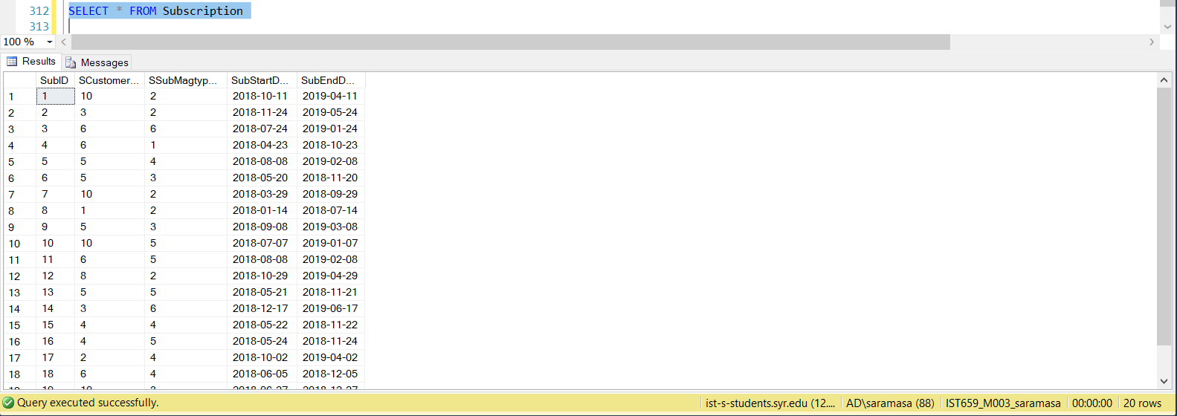

--INSERT INTO SUBSCRIPTION TABLE

INSERT INTO EXPENDITURE VALUES (1,'VOG',1,487,880,1406,1900,2394)

INSERT INTO EXPENDITURE VALUES (2,'VOG',2,470,735,1004,1778,2191)

INSERT INTO EXPENDITURE VALUES (3,'VOG',3,432,528,1011,1977,2112)

INSERT INTO EXPENDITURE VALUES (4,'VOG',4,472,579,1467,1540,2162)

INSERT INTO EXPENDITURE VALUES (5,'VOG',5,365,860,1031,1717,2342)

INSERT INTO EXPENDITURE VALUES (6,'VOG',6,421,994,1272,1656,2216)

INSERT INTO EXPENDITURE VALUES (7,'VOG',7,356,933,1250,1666,2366)

INSERT INTO EXPENDITURE VALUES (8,'VOG',8,405,663,1317,1811,2196)

INSERT INTO EXPENDITURE VALUES (9,'VOG',9,405,687,1207,1832,2014)

INSERT INTO EXPENDITURE VALUES (10,'VOG',10,344,728,1142,1813,2466)

INSERT INTO EXPENDITURE VALUES (11,'VOG',11,495,873,1098,1586,2386)

INSERT INTO EXPENDITURE VALUES (12,'VOG',12,469,547,1168,1860,2025)

INSERT INTO EXPENDITURE VALUES (13,'VOG-E',13,356,512,1312,1595,2418)

INSERT INTO EXPENDITURE VALUES (14,'VOG-E',14,499,914,1064,1616,2367)

INSERT INTO EXPENDITURE VALUES (15,'VOG-E',15,289,742,1196,1700,2210)

INSERT INTO EXPENDITURE VALUES (16,'VOG-E',16,435,528,1435,1907,2037)

INSERT INTO EXPENDITURE VALUES (17,'VOG-E',17,363,529,1074,1734,2168)

INSERT INTO EXPENDITURE VALUES (18,'VOG-E',18,443,721,1443,1845,2160)

INSERT INTO EXPENDITURE VALUES (19,'VOG-E',19,497,580,1372,1566,2491)

INSERT INTO EXPENDITURE VALUES (20,'VOG-E',20,333,923,1238,1784,2374)

INSERT INTO EXPENDITURE VALUES (21,'VOG-E',21,363,529,1074,1734,2168)

INSERT INTO EXPENDITURE VALUES (22,'VOG-E',22,363,529,1074,1734,2168)

INSERT INTO EXPENDITURE VALUES (23,'VOG-E',23,363,529,1074,1734,2168)

INSERT INTO EXPENDITURE VALUES (24,'VOG-E',24,363,529,1074,1734,2168)

SELECT * FROM Expenditure

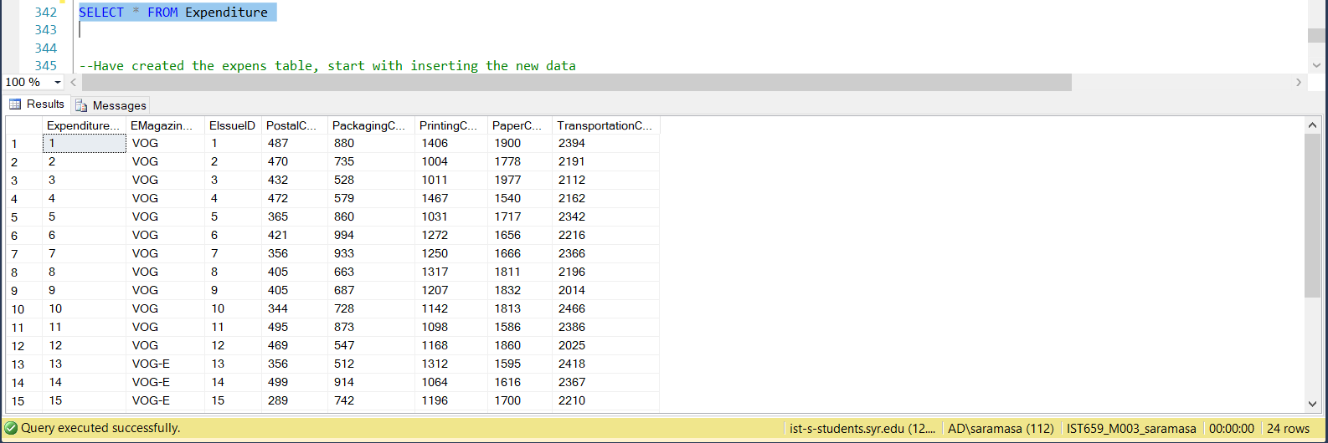

# MAJOR DATA QUESTIONS

1. What is the Total Revenue for the month of July 2018?

select sum(s3.SubCost) as Total_Revenue from (select s1.SubID,s2.SubCost from Subscription s1 join SubMagType s2 on s1.SSubMagtypeID=s2.SubMagTypeID where s1.SubStartDate between '2018-07-01' and '2018-07-31') as s3

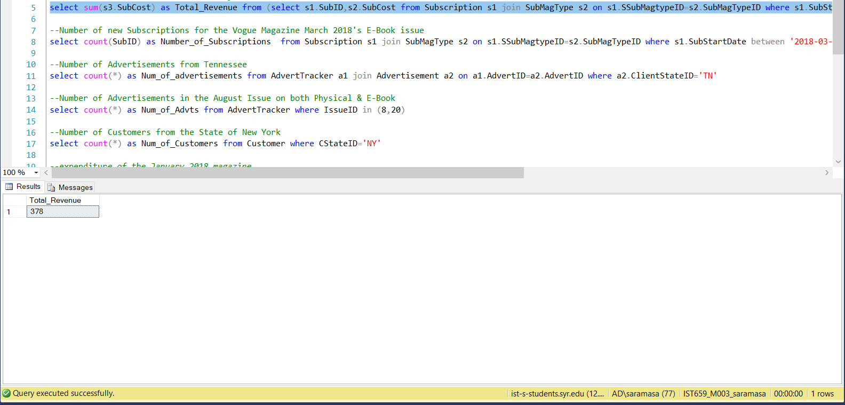

1. What is the total Number of new Subscriptions for the Vogue Magazine March 2018's E-Book issue?

select count(SubID) as Number_of_Subscriptions from Subscription s1 join SubMagType s2 on s1.SSubMagtypeID=s2.SubMagTypeID where s1.SubStartDate between '2018-03-01' and '2018-03-31'

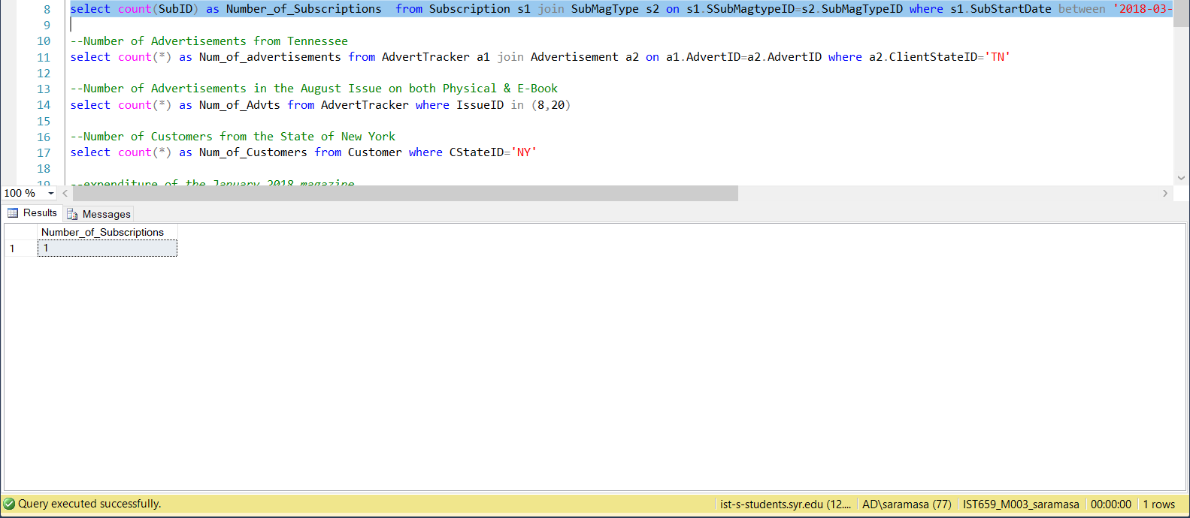

1. What is the total Number of Advertisements from Tennessee?

select count(*) as Num_of_advertisements from AdvertTracker a1 join Advertisement a2 on a1.AdvertID=a2.AdvertID where a2.ClientStateID='TN'

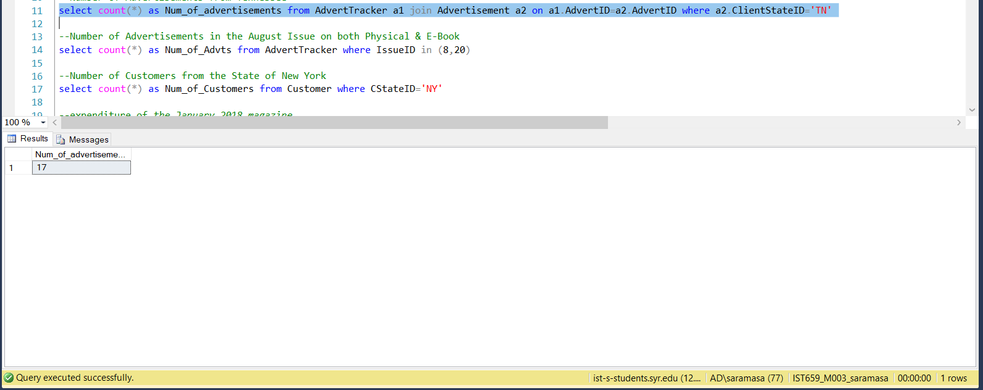

1. Whatis the Number of Advertisements in the August Issue on both Physical & E-Book?

select count(*) as Num_of_Advts from AdvertTracker a join Issue i on a.IssueID=i.IssueID where i.Month='August'

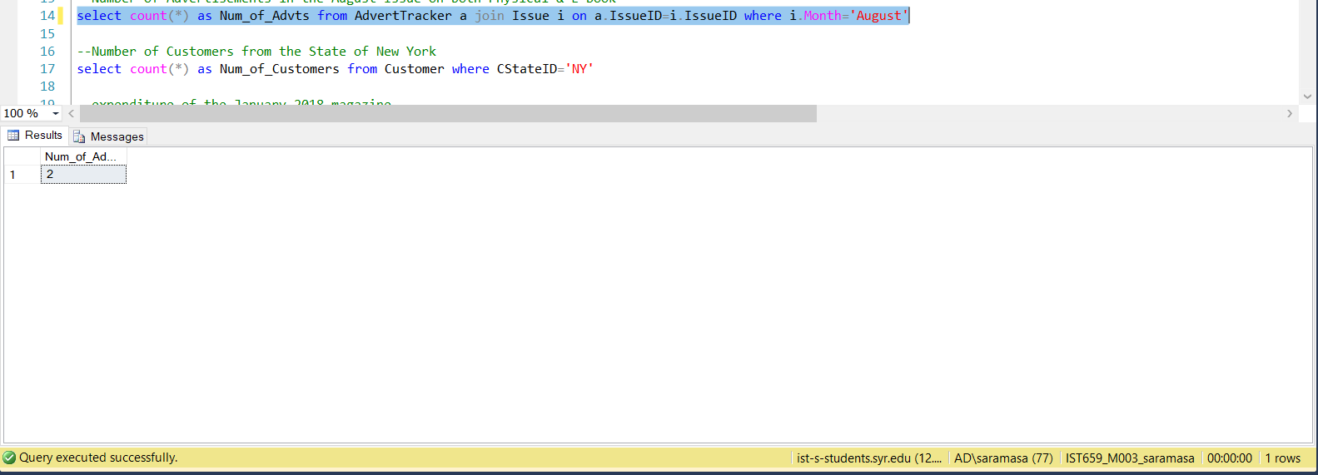

1. What is the Total Number of Customers from the State of New York?

select count(*) as Num_of_Customers from Customer where CStateID='NY'

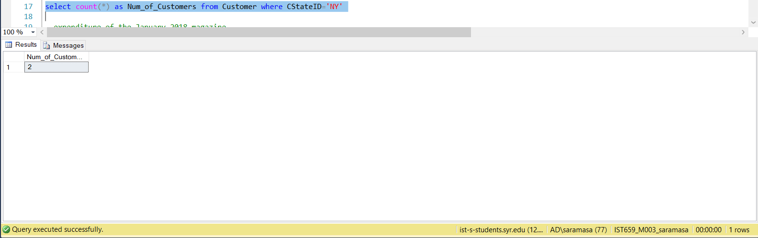

1. What is the Total expenditure of the January 2018 magazine?

select i.IssueID, i.Month , (PostalCost+PackagingCost+PrintingCost+PaperCost+TransportationCost) as Total_Cost from Expenditure e join Issue i on e.EIssueID=i.IssueID where EIssueID in (select IssueID from Issue i where Month='January')

# INTERFACES

1. Login Page:

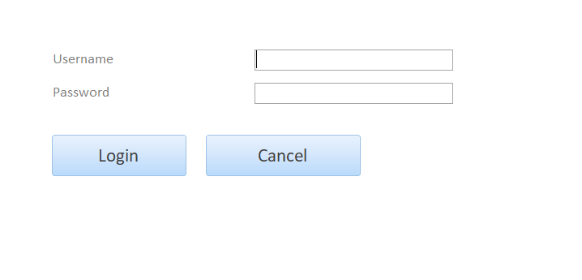

1. Home Page:

After logging in, the user is greeted with the home page or the navigation page.

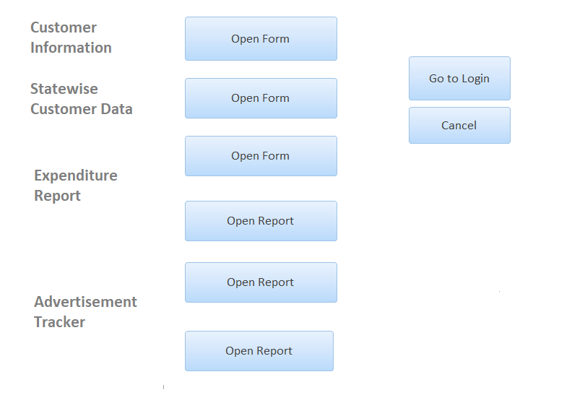

1. Customer Data Form:

Here we have a form to View, Add, Delete, Save & Print the data related to the Customers.

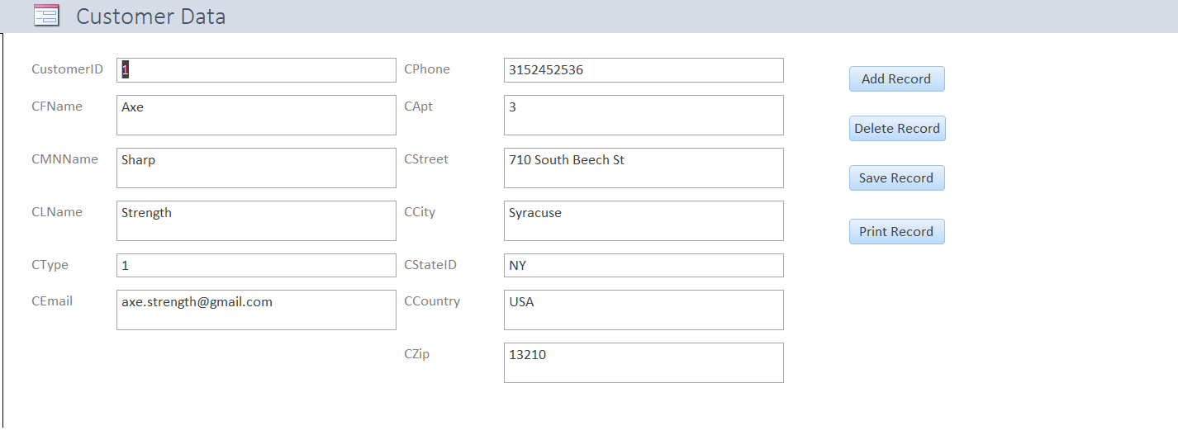

1. State wise Customers:

In this form we can view the customers according to their state of residency.

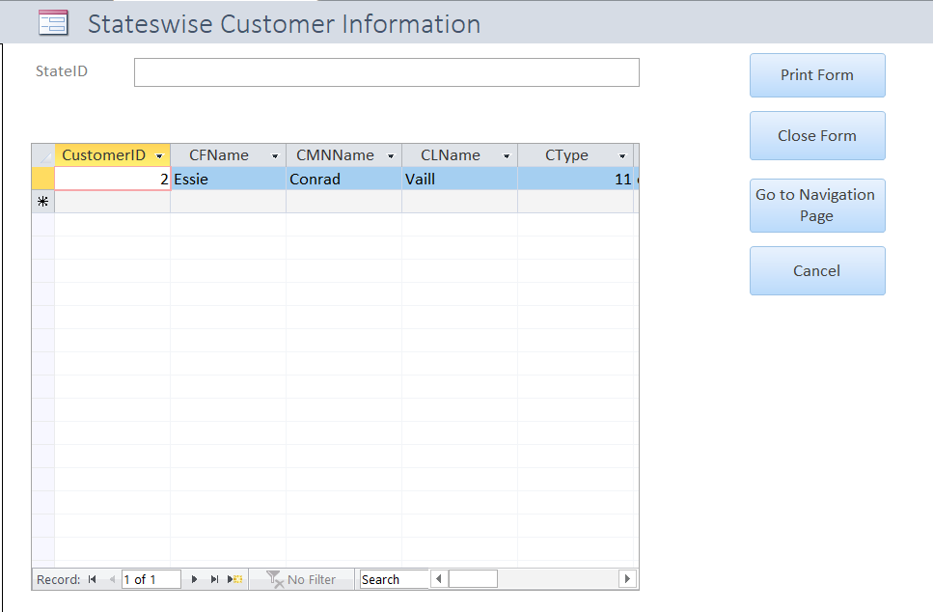

1. State-wise Advertisements:

Here we can view all the advertisements that were received in each and every state.

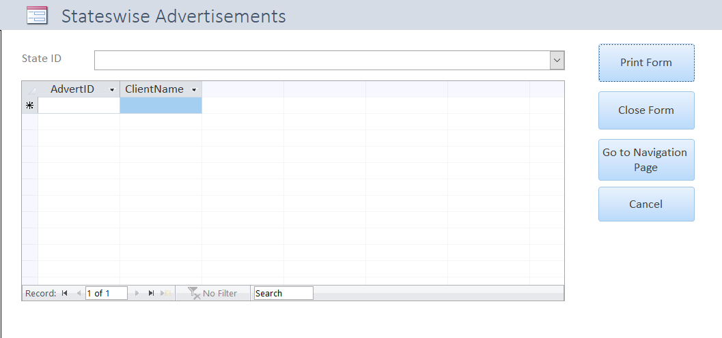

# REPORT

1. Expenditure:

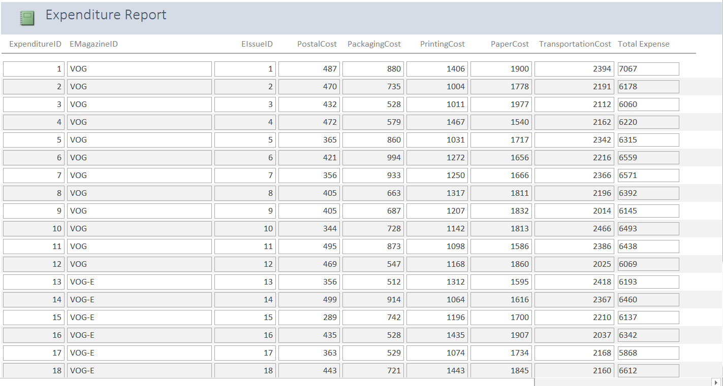

1. Magazine Subscription Cost:

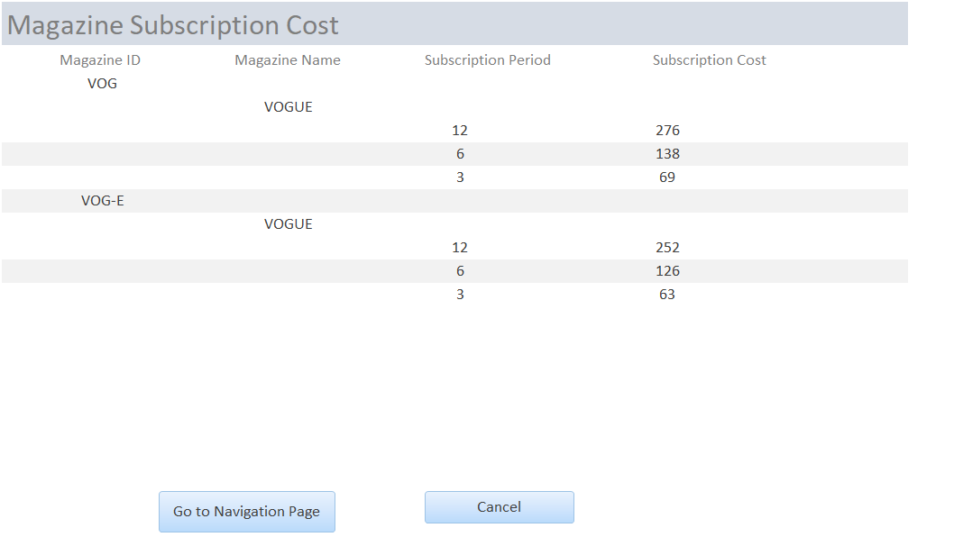

1. Subscription Revenue

